**Exercise: Sorting data**

[Adventure Works Inventory](https://d3c33hcgiwev3.cloudfront.net/thgZ9WJSSjSfGBO41sT9Vg_851b0cfdbb8c4605b0971707cd6fa4e1_Adventure-Works-Inventory.xlsx?Expires=1708473600&Signature=ZcmA7AOvvcffUHb~Sg0ozjH7i7nbXorI~BWzI4aOfkOUHfQrZSUT68WL8CahF-ibeTDWt2g~XybmSBLantmp1Hu~eO1FAklpgGdMb89dSGRdiO5EiHsCz4LhrYznVyJ~8N~Og3n5VTefBflwNoqxvby4dk7KJafN7U1heGwdI0E_&Key-Pair-Id=APKAJLTNE6QMUY6HBC5A" \t "_blank)

[XLSX File](https://d3c33hcgiwev3.cloudfront.net/thgZ9WJSSjSfGBO41sT9Vg_851b0cfdbb8c4605b0971707cd6fa4e1_Adventure-Works-Inventory.xlsx?Expires=1708473600&Signature=ZcmA7AOvvcffUHb~Sg0ozjH7i7nbXorI~BWzI4aOfkOUHfQrZSUT68WL8CahF-ibeTDWt2g~XybmSBLantmp1Hu~eO1FAklpgGdMb89dSGRdiO5EiHsCz4LhrYznVyJ~8N~Og3n5VTefBflwNoqxvby4dk7KJafN7U1heGwdI0E_&Key-Pair-Id=APKAJLTNE6QMUY6HBC5A" \t "_blank)

**Introduction**

By now you should be familiar with the sorting feature in Microsoft Excel. In this exercise, you’ll reorganize the data in a worksheet so that rows are grouped in a particular order. You’ll do this by using both standard and multi-level sorts. By completing this exercise, you’ll be able to use these skills to sort numbers and text on large worksheets in a focused way.

**Case study**

Jamie at Adventure Works wants to improve the company’s product inventory file. This includes making the data easier to read and locate. You are part of the team creating the inventory for submission to a management review. You are familiarizing yourself with the content in the inventory file and decide to use the **Sort** feature to organize the data to suit your requirements.

**Step 1: Download and customize the file**

1. Download and open the Microsoft Excel workbook *Adventure Works Inventory.xlsx*. The file should contain one worksheet named **Products** that consists of 151 rows and 9 columns.

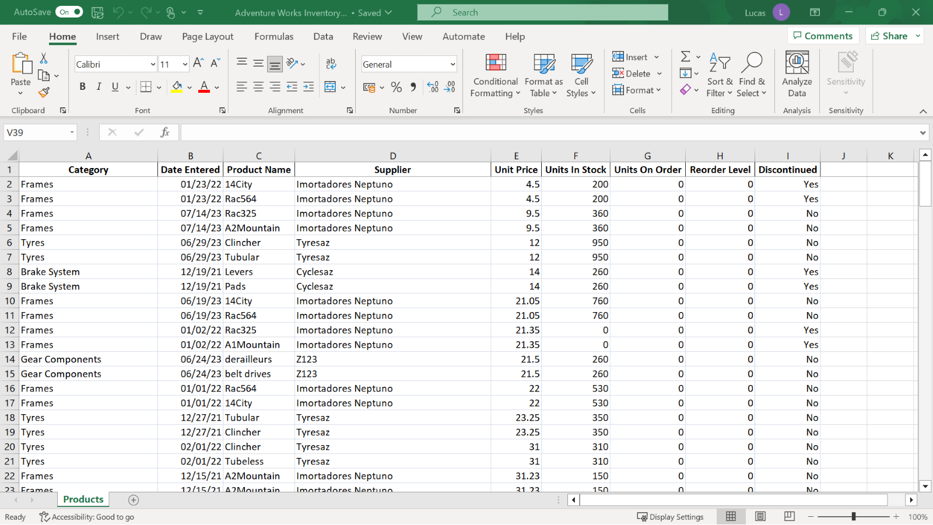

1. You are using the **Sort** feature to rearrange the data. So, add a visual marker in the data to determine the effects of the different sorts. Select cells **A32** to **I32** and apply a yellow background. On the **Home** tab, select the **Font** group, then select the **background color.**

**Step 2: Performing alpha-numeric sorts**

1. View the data organized by **Product Name** in ascending order.

**Tip:** Don’t forget to have the cursor in the correct column before selecting the **Sort** choice. Also, don’t forget that **Undo** will reverse a sort if you’ve made an error. Monitor the position of the colored row to ensure that the sort is working as you expect.

1. Sort the data by **Product Name** in descending order.
2. Sort the data by **Date Entered** so that the oldest entry is at the top.

**Tip:** Excel stores dates as numbers, so this will be a numeric sort.

1. Sort the data by **Supplier** using the shortcut **Sort Ascending** button.
2. Apply a sort that sorts the data by **Supplier** in ascending order and then by **Units in Stock** in descending order.

**Tip:** Remember the **Sort** choice in the data ribbon.

1. Reverse this sort using the **Undo** feature.

**Conclusion**

You have helped Adventure Works to re-organize its product inventory file using the **Sort** feature in Microsoft Excel. The **Sort** feature in Microsoft Excel can help you to reorganize data in many ways. By using these sorting techniques, you can work more efficiently and quickly with large worksheets.

**Exemplar: Sorting data**

**Overview**

In the exercise *Sorting Data* you had to use the Sort feature to reorganize the data so that you could become more familiar with it.

More specifically, you were instructed to complete the following tasks in the worksheet:

* Sort text and numeric data.
* Perform a multi-level **Sort**.

This reading provides you with a step-by-step guide for this process and includes screenshots that you can compare against your own copy. You can also review sorting techniques in the video *Sorting and filtering data in Excel*.

**Step 1: Getting Started**

1. Download the *Adventure Works Inventory.xlsx* file and open it in Microsoft Excel. The workbook contains only one worksheet called **Products**.
2. Highlight the cells **A32** to **I32** and apply a yellow background. From the **Home** tab, select the **Font** group then select the **background color.** This provides a reference point for when the data is being sorted.

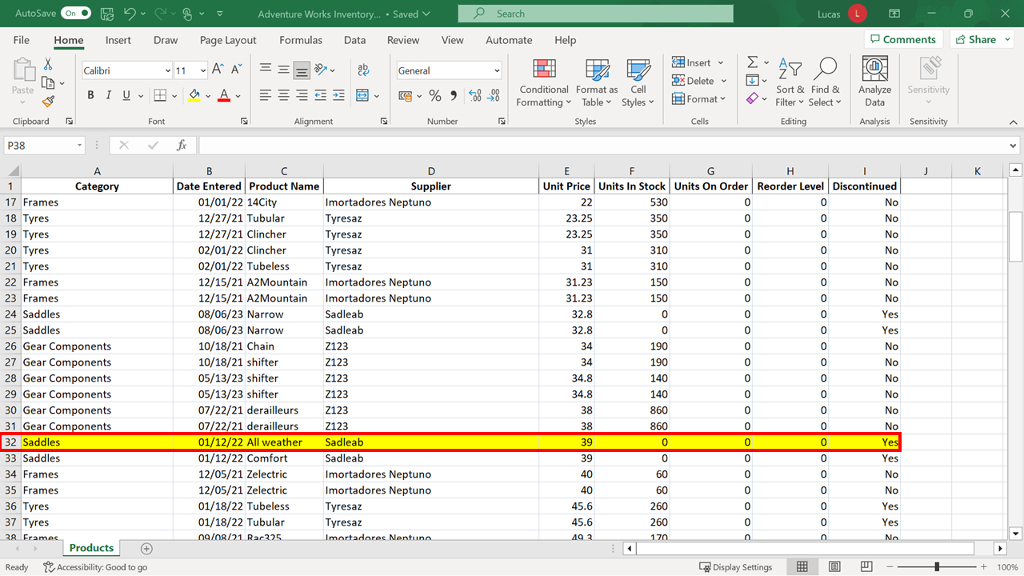

**Step 2: Sorting the Data**

1. You want to view the data organized by **Product Name**. Position the cursor in column **C**. On the **Data** ribbon select **Sort A to Z**.

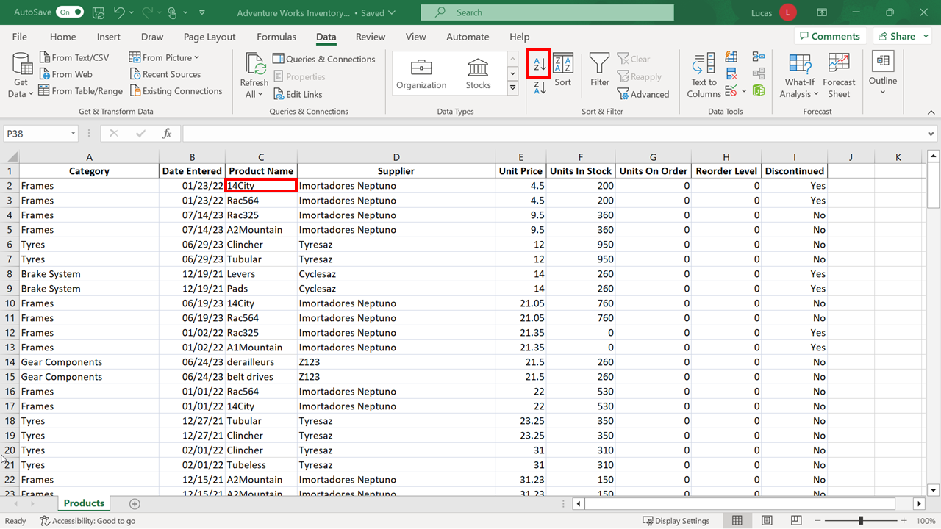

Excel performs an alpha-numeric sort on the data. The text entries appear alphabetically. Any entries starting with a number are positioned at the top of the column.

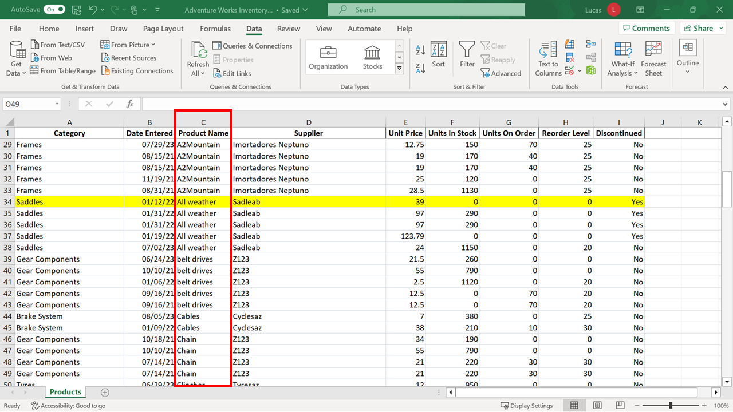

The row that you have shaded yellow has moved to a new location. It is now row **34**.

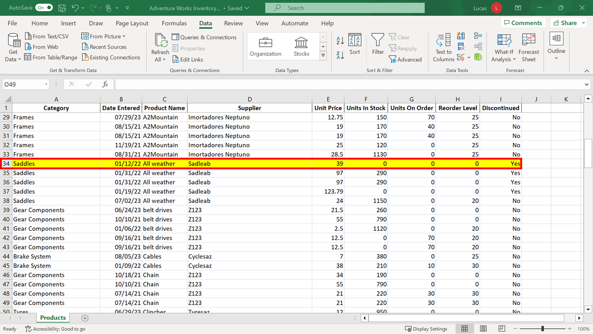

1. You need to view data organized by **Product Name** in descending order. Position the cursor in the **Product Name** column. On the **Data** ribbon choose **Sort Z to A**.

The data block is now resorted. The sort key is still the **Product Name** entries but they appear in reverse order. The row shaded yellow has now moved to row **115**.

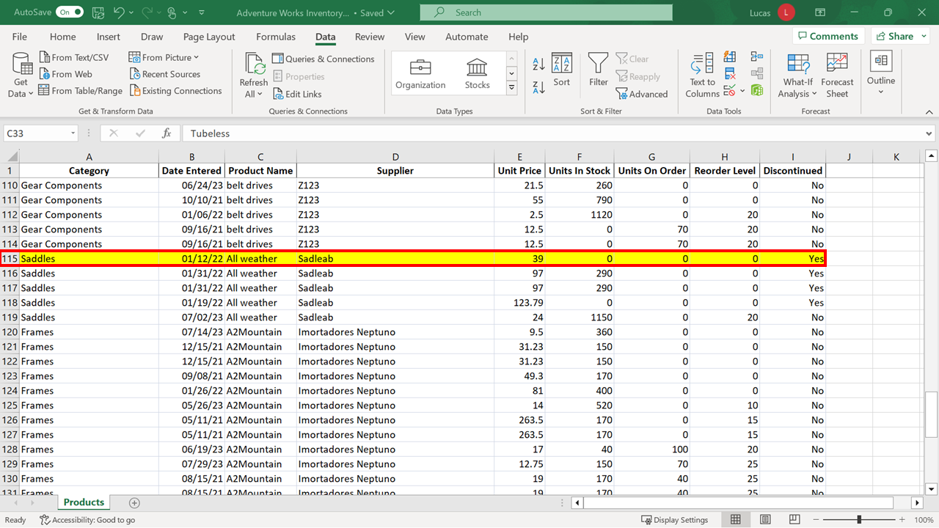

There are still blocks of rows containing the same **Category** entries grouped together because of the way that the information is structured. It would be easy to misinterpret the display of information and believe that row **13** was the last entry for frames, which is not the case.

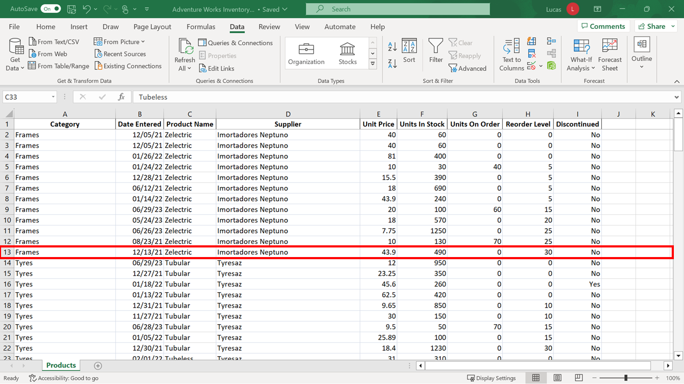

There are additional entries for frames beginning on row **41**.

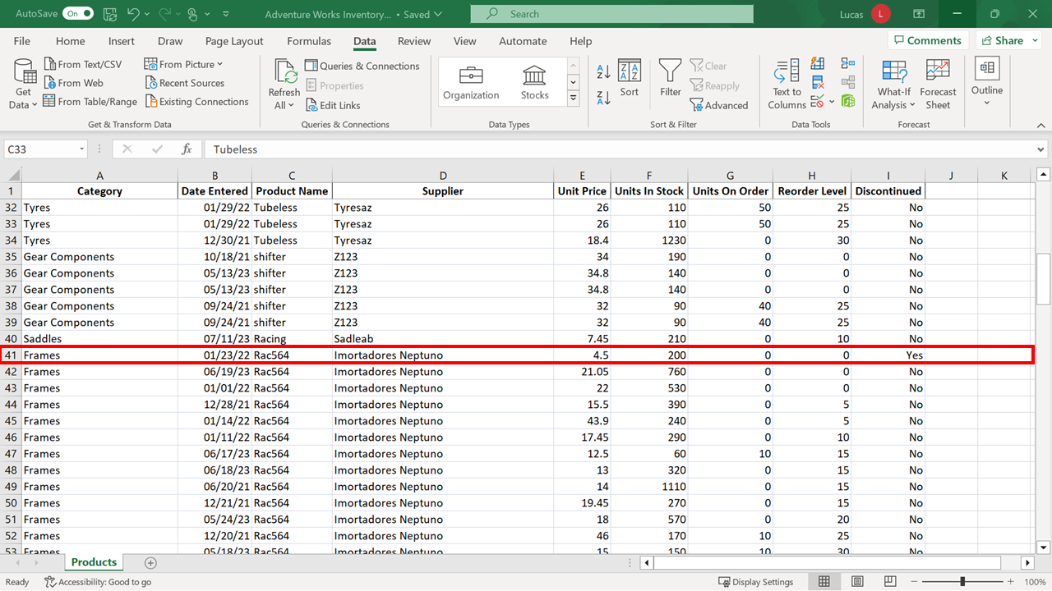

And on row **120**.

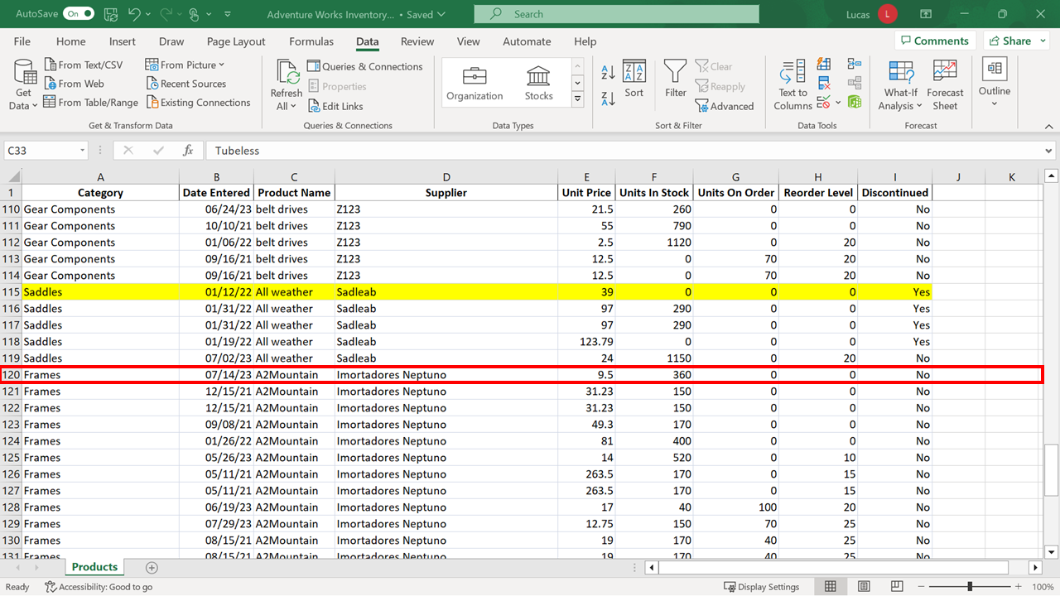

1. Next, you need to sort the data so that the oldest entry is on top. Move the cursor to column **B** which contains the date information. With the cursor in this column, select the **Sort ascending** choice (the **A-Z** button). Excel performs a numeric sort on the data which means that it now appears in date order. The row shaded yellow has been repositioned again and now appears as row **77**.

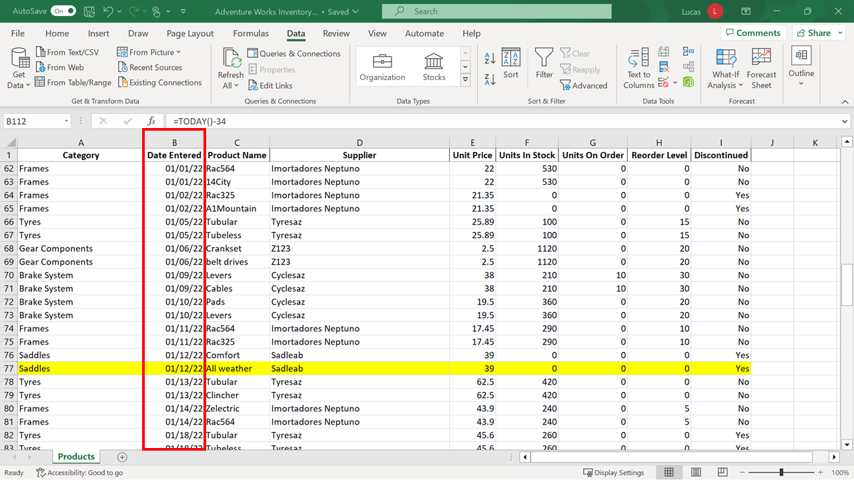

1. Next, you need to sort the data by **Supplier** in ascending order. Position the cursor in the **Supplier** column and then select **Sort** **A to Z** to accomplish this.

A common error is to select a whole column before choosing **Sort**. If you select the column letter **D**, the whole column is highlighted. A warning dialog would appear if you then choose **Sort A to Z** because Excel is aware that there is data around the block of cells you highlighted.

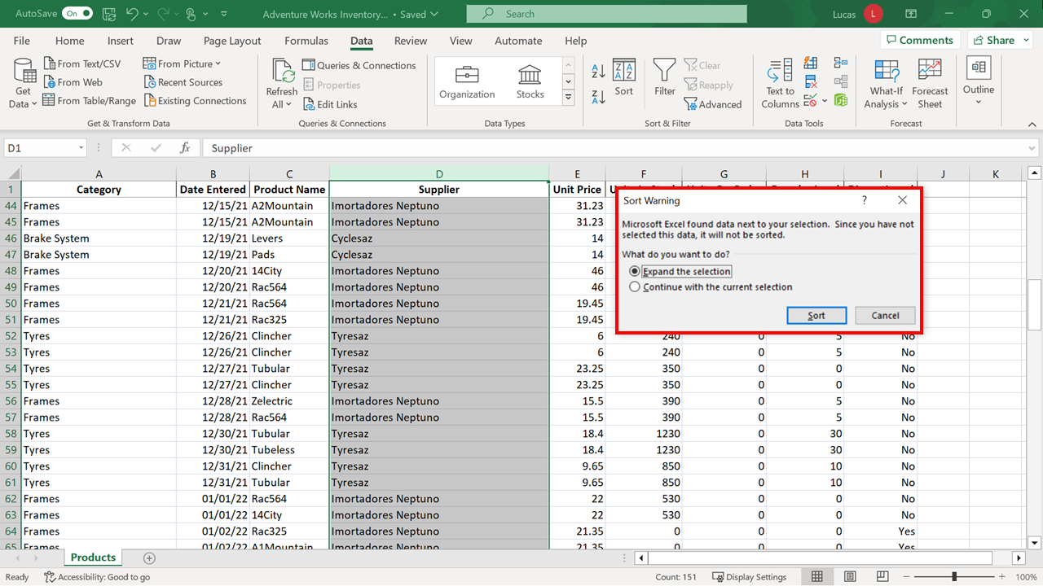

If you selected the **Continue with the current selection** choice in the warning dialog, Excel would sort the content in column **D** independently of the related information in each row.

You can appreciate how this choice made incorrectly, could create serious errors.

**Tip:** If you make a mistake in sorting, you can select **Undo** to reverse the sort and restore the entries to their correct positions.

If you have selected column **D** to see this **Sort Warning** dialog, select a cell anywhere in the spreadsheet to cancel the highlight.

1. You now need to sort the data by two criteria which cannot be achieved using the shortcut **Sort A to Z** or **Sort Z to A** choices. These choices are designed to carry out a single sort. Instead, you select **Sort** from the **Data** tab to begin a multi-level sort operation.

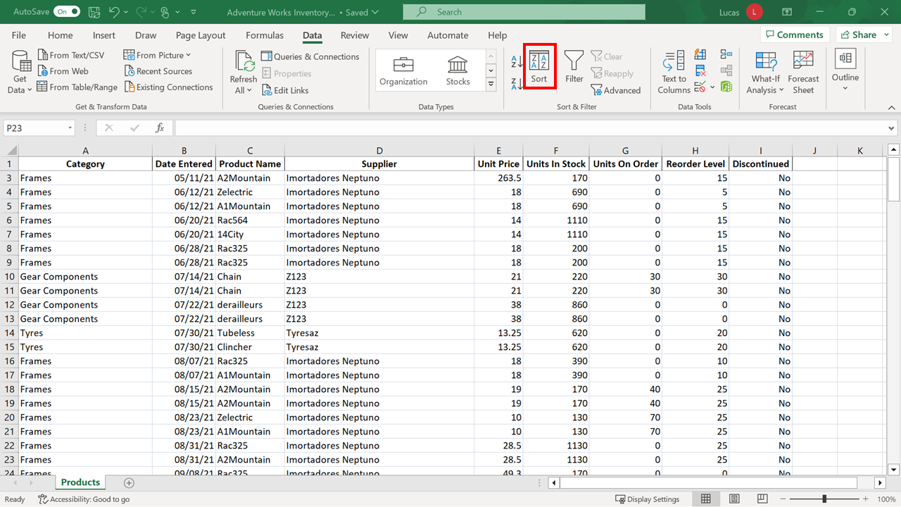

The **Sort** dialog opens with drop-down choices which allow you to customize and control the sort. In the first **Column** drop-down, select **Supplier**.

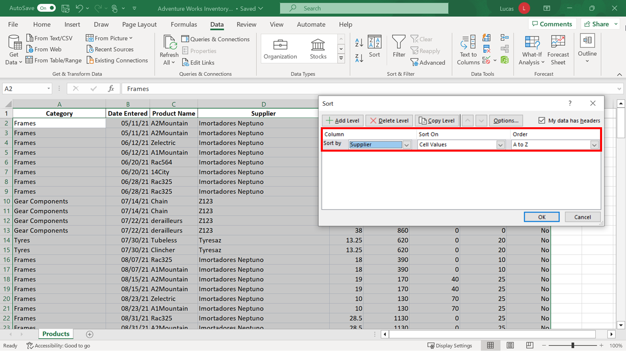

The **Sort On** selection is correctly set to **Cell Values**.

**Tip:** If you click on the drop-down, you will see that it is possible to sort by color in a spreadsheet. (Color can be generated automatically in a spreadsheet using a feature called **Conditional Formatting**. Please refer to the page *Use Conditional Formatting to Highlight information* in the *Additional Resources* reading.)

When you select the **Add Level** choice in the top left of the dialog, another sort line is added. Note that it begins on the left with the words “**Then By**”. This means that the choices made on this line will be the secondary sort. Select **Units in Stock** in the column drop-down and **Largest to smallest** in the **Order** column. Select **OK**.

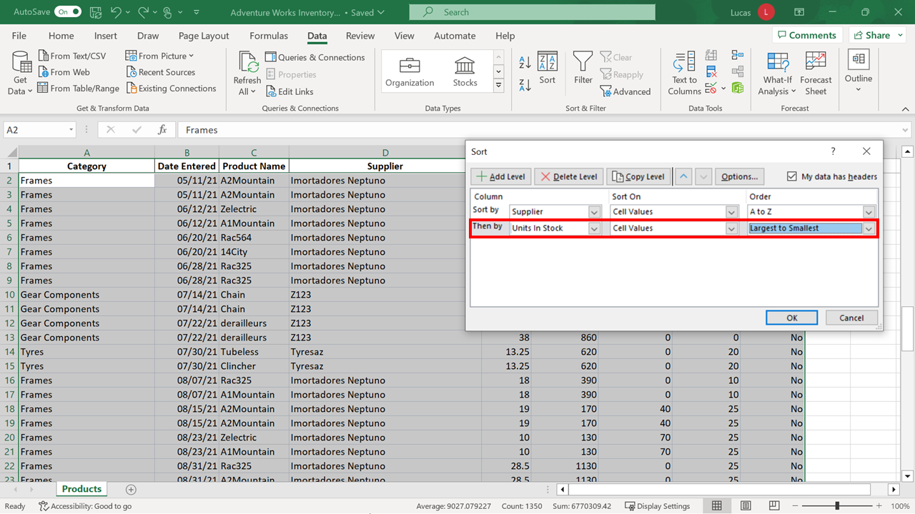

The Sadleab **Supplier** entries are grouped together. The entries are further sorted by **Units in Stock**.

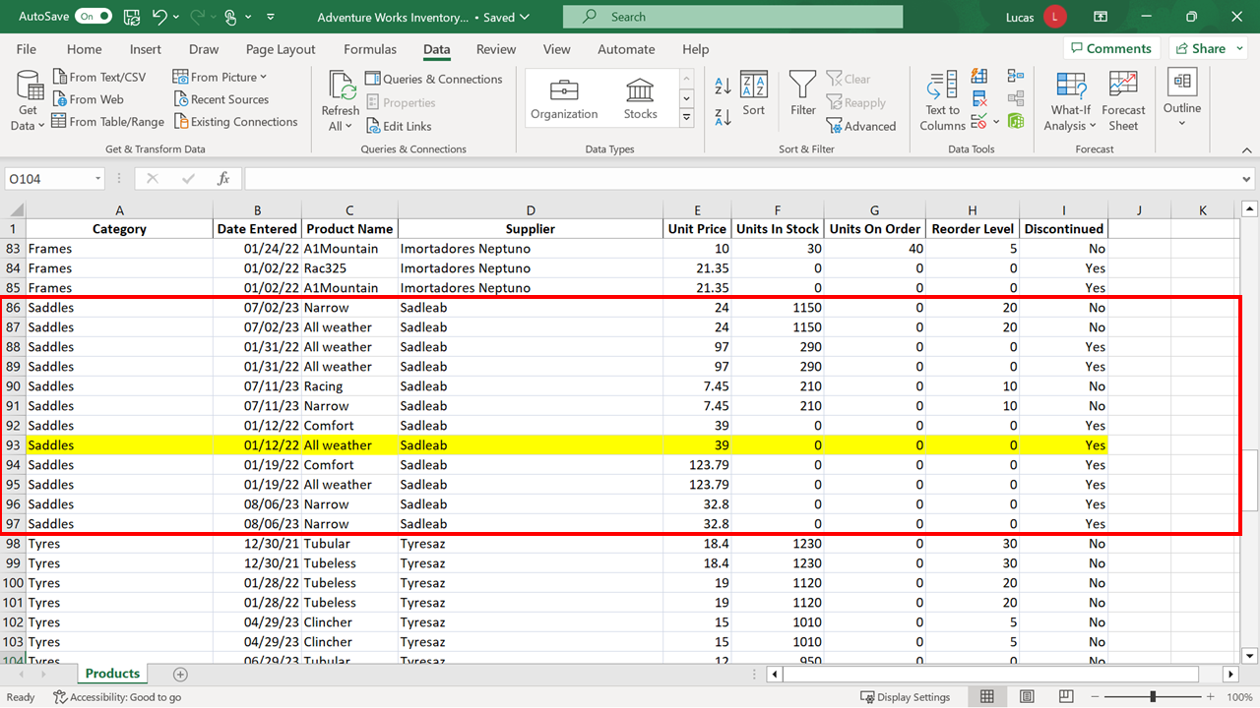

**Conclusion**

Congratulations! You have successfully completed this exercise. You now know how to sort data in a worksheet when different orders are required.